EXP:1 Implement and demonstrate the FIND-S algorithm for finding the most specific hypothesis based on a given set of training data samples.

Aim
To implement the FIND-S algorithm and determine the most specific hypothesis that is consistent with all positive training examples.

Algorithms
- Initialize the hypothesis with the most specific values (Ø).
- Read each training example.
- If the example is positive:
  - Compare each attribute with the hypothesis.
  - If they are different, replace the hypothesis value with ?.
- Ignore all negative examples.
- Display the final hypothesis.

CODE
# Define the training data
# Each row represents an example, and the last column is the target concept (enjoy sport)
data = [
['Sunny', 'Warm', 'Normal', 'Strong', 'Warm', 'Same', 'Yes'],
['Sunny', 'Warm', 'High', 'Strong', 'Warm', 'Same', 'Yes'],
['Rainy', 'Cold', 'High', 'Strong', 'Warm', 'Change', 'No'],
['Sunny', 'Warm', 'High', 'Strong', 'Cool', 'Change', 'Yes']
]

# Define attribute names
attributes = ['Sky', 'AirTemp', 'Humidity', 'Wind', 'Water', 'Forecast', 'EnjoySport']

# Create a DataFrame
df = pd.DataFrame(data, columns=attributes)
display(df)

OUT PUT
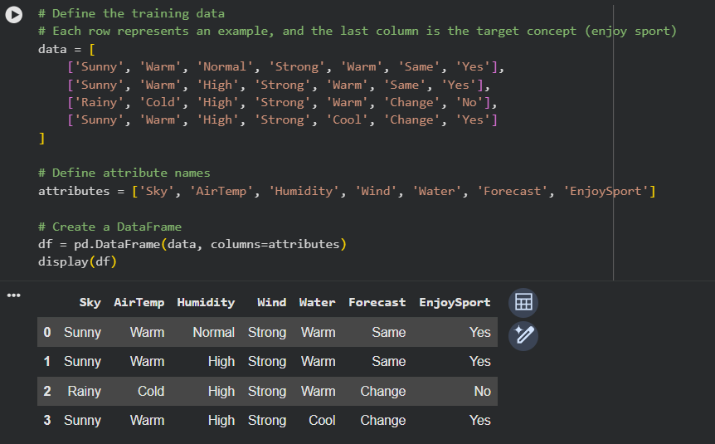

Result
The FIND-S algorithm successfully generated the most specific hypothesis consistent with all positive training examples.

